# **Python Assignment - Grade & File Handling**

## **1. Grade Checker**

Code:

score = int(input("Enter your score: "))

if score >= 90:

print("Grade: A")

elif score >= 80:

print("Grade: B")

elif score >= 70:

print("Grade: C")

elif score >= 60:

print("Grade: D")

else:

print("Grade: F")

Explanation:

* Takes a score as input from the user.
* Uses if-elif-else conditions to check the score range.
* Prints the corresponding grade.

🖼 Screenshot:  
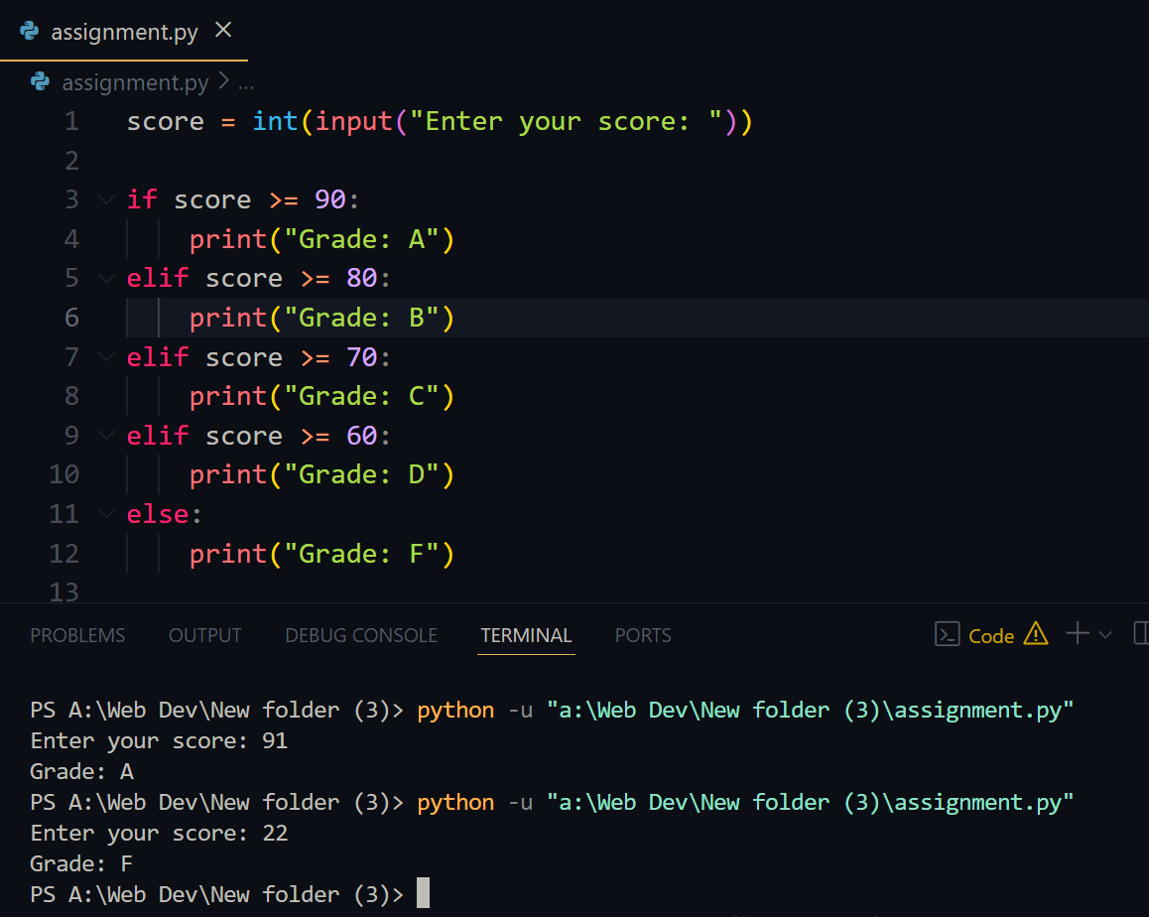

## **2. Student Grades (Dictionary Operations)**

Code:

grades = {}

while True:

print("\n1. Add Student\n2. Update Grade\n3. View All Grades\n4. Exit")

choice = input("Choose an option: ")

if choice == "1":

name = input("Enter student name: ")

grade = input("Enter grade: ")

grades[name] = grade

print(f"{name}'s grade added.")

elif choice == "2":

name = input("Enter student name to update: ")

if name in grades:

grade = input("Enter new grade: ")

grades[name] = grade

print(f"{name}'s grade updated.")

else:

print("Student not found.")

elif choice == "3":

print("\nStudent Grades:")

for name, grade in grades.items():

print(f"{name}: {grade}")

elif choice == "4":

break

else:

print("Invalid choice.")

Explanation:

* A dictionary stores student names and their grades.
* User can add a student, update a grade, view all grades, or exit.
* Uses if-else, loop, and dictionary methods.

🖼 Screenshot:  
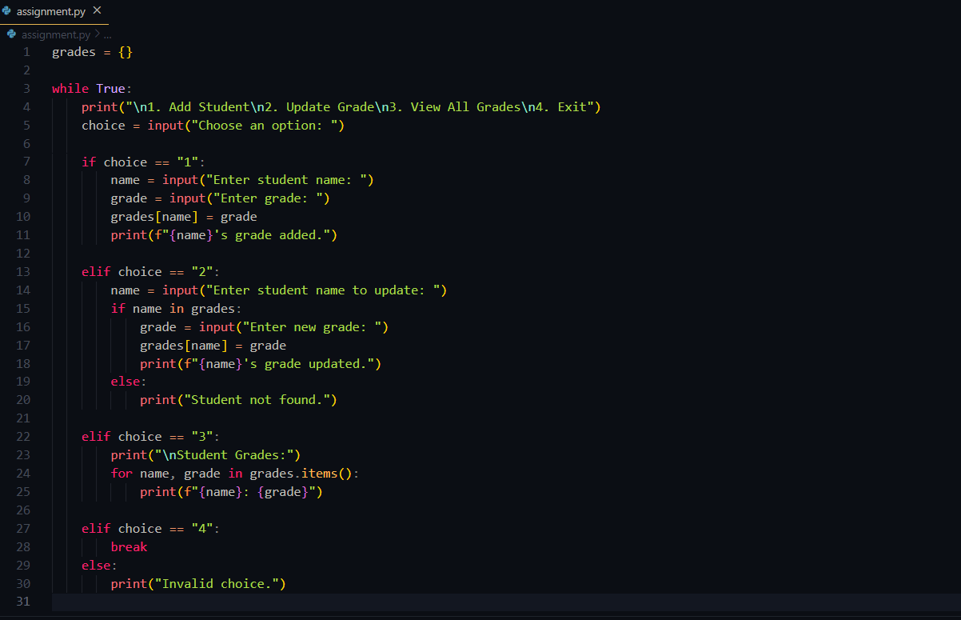 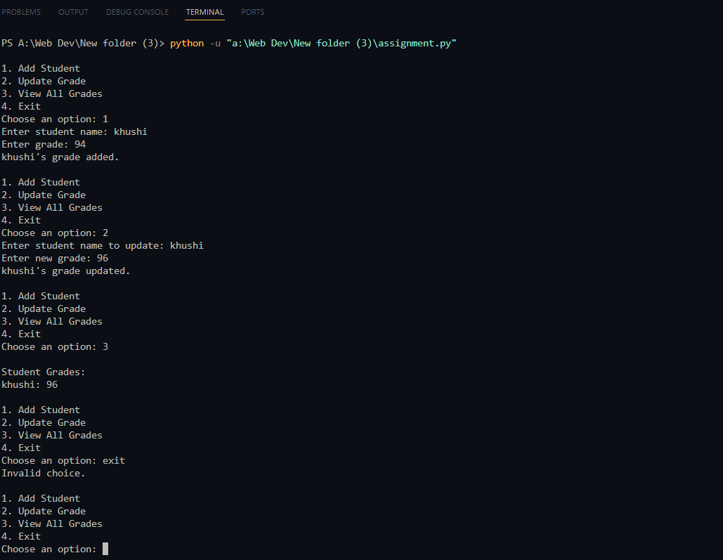

## **3. Write to a File**

Code:

file = open("sample.txt", "w")

file.write("Hello! This is a sample file.\nThis file is written using Python.")

file.close()

print("File written successfully.")

Explanation:

* Opens (or creates) a file in write mode.
* Writes text to it using write().
* Closes the file using close().

🖼 Screenshot:

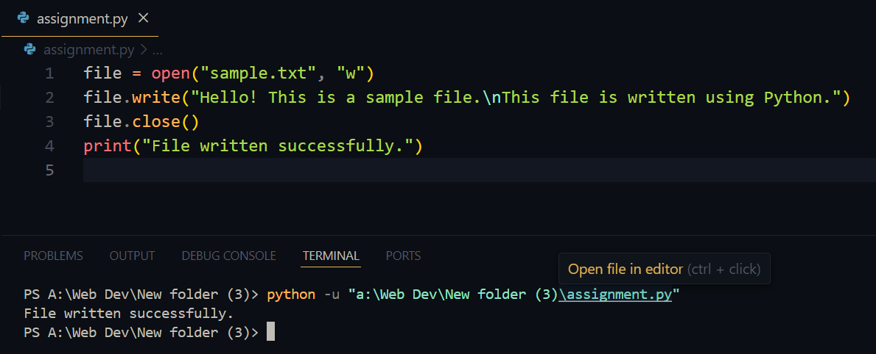

## **4. Read from a File**

✅ Code:

lua

CopyEdit

file = open("sample.txt", "r")

content = file.read()

file.close()

print("Content of file:")

print(content)

📝 Explanation:

* Open the file in read mode using "r".
* Reads content using read() and prints it.
* Closes the file after reading.

🖼 Screenshot:  
